**Canny Edge Detector**

Lab Report: Assignment 3

Course: CS4650

Date: 10/15/2019

**Objective:**

For assignment 1, we need to know how to do the implement the Canny edge detection algorithm

**Assignment description:**

I need to do the filtered gradient firstly, and then I need to get Non-maximum suppression. Finally, I use Hysteresis thresholding to get the Canny edge.

**Implementation:**

**Filtered gradient:**

Firstly, Same as assignment 2, I get need to get Gaussian filtering. I need to set the standard derivation of the distribution. Then I set 5x5 kernel, and I use double for-loop statement to get the Gaussian Filter that is 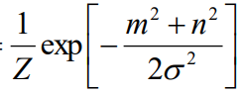

Then I use padarray method to apply the filter to image, and I just use two for-loop statements to set Gaussian filtering. And finally I can get the result.

**Result for figure Lena**

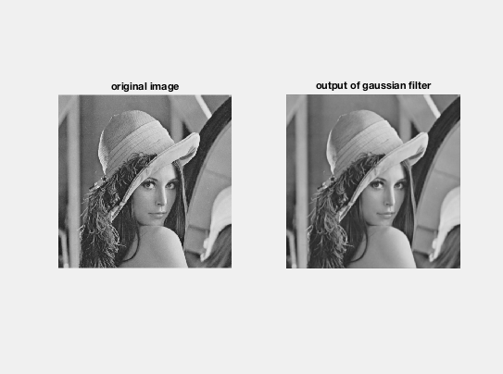

**Compute the Gradient:**

Firstly, I need to convolve the guassian filtered image with Prewitt or Sobel operator. Thus, I make two arrays which they are FxSobel, Fy Sobel, and then I used conv2 method to convolve FXSobel and FYSobel with guassian filter image. And then I can get the image Fx and Fy. Fx shows the magnitude of the guassian filtered image, and Fy is orientation of the guassian filtered image. And then I use the formula that is (Fx^2+Fy^2)^0.5, then I can get magnitude of the Gradient. Finally, I use ‘atan2’ method to compute Fx and Fy, to get orientation of the Gradient.

**Result for figure Lena**

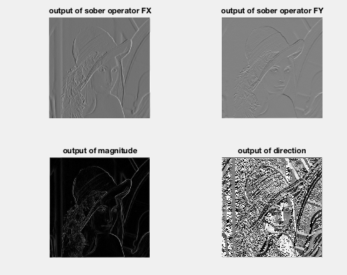

**Nonmaximum suppression:**

For each pixel, I need to find the direction D in (0, 45, 90, 135, 180, 225, 270, 315), so I use if- statement to check each pixel. If pixel is between 22.5 and -22.5, I set it to be 0, and pixel is between 22.5 and 67.5, I set it to be 45, and pixel is between 67.5 and 112.5, I set it to be 90, and pixel is between 112.5 and 157.5, I set it to be 135, and pixel is between 157.5 and 202.5, I set it to be 180 and pixel is between 202.5 and 247.5, I set it to be 225, and pixel is between 247.5 and 292.5, I set it to be 270, and pixel is between 292.5 and 337.5, I set it to be 315. And then If the edge strength F(x,y) is smaller than at least one of its neighbors along D*, set I(x,y) = 0, else set I(x,y) = F(x,y). Thus, I have four condition that are direction on x coordinate, direction on y coordinate, direction on diagonal one, and direction on diagonal two to check. Then, I show the I(x,y) which it is imageF with non- maximum suppression.

**Result for figure Lena**

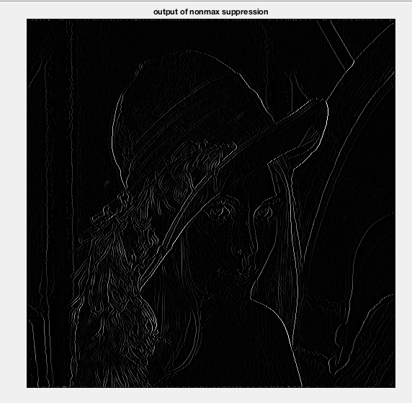

**Hysteresis thresholding:**

For this part, I need to Set threshold T_h is 150 and T_l is 10, and then locate the next unvisited pixel (x,y) such that I(x,y) > T_h, and I(x,y)=255. And I(x,y)<T_l, I(x,y)is 0. Then I can the result.

**Result for figure Lena:**

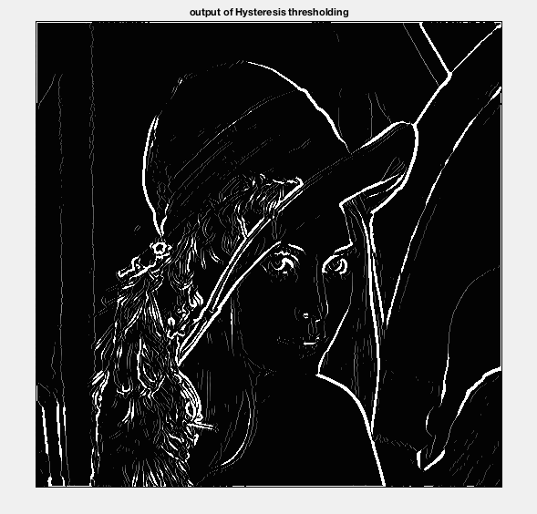

**Discussion:**

For this lab, I learned how to use matlab to do the Canny Edge Detector step by step. Thus, I need to do filtered gradient firstly, and then I need to get Non-maximum suppression. Finally, I use Hysteresis thresholding to get the Canny edge.